DEVELOPING SCALA MAVEN PROJECT FROM COMMAND LINE

Open command prompt and type mvn archetype:generate

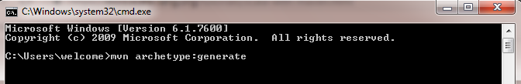

Maven will display the list of archetypes

Choose the correct scala-archetype-simple archetype and select the version

Give the groupId, artifactId, version and package and confirm it

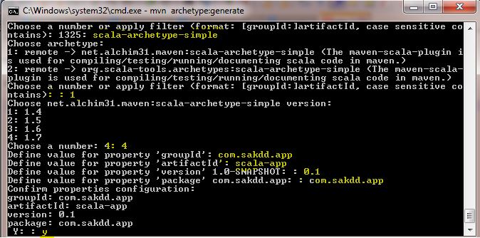

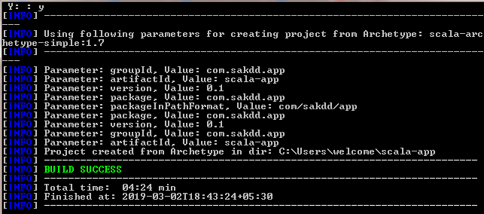

Once it is done, go to the project folder and do mvn package

C:\Users\welcome\Desktop\step 4.PNG

It will download all the scala dependencies and create the jar

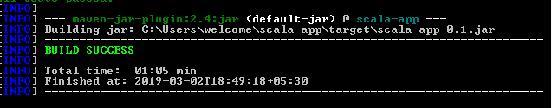

The basic project structure will be

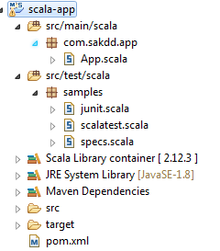

The jar created by the Scala Maven Plugin does not include Main Class attribute in the manifest so we have to add the Maven Assembly Plugin to our pom.xml

The Assembly Plugin for Maven is primarily intended to allow users to aggregate the project output along with its dependencies, modules, site documentation, and other files into a single distributable archive.

<plugin>

<groupId>org.apache.maven.plugins</groupId>

<artifactId>maven-assembly-plugin</artifactId>

<version>2.5.3</version>

<configuration>

<descriptorRefs>

<descriptorRef>jar-with-dependencies</descriptorRef>

</descriptorRefs>

<archive>

<manifest>

<mainClass>fully-qualified-main-class-name</mainClass>

</manifest>

</archive>

</configuration>

<executions>

<execution>

<phase>package</phase>

<goals>

<goal>single</goal>

</goals>

</execution>

</executions>

</plugin>

for us the main class name is com.sakdd.app.App

Once the plugin is added do mvn package again it will generate one more jar with all dependencies

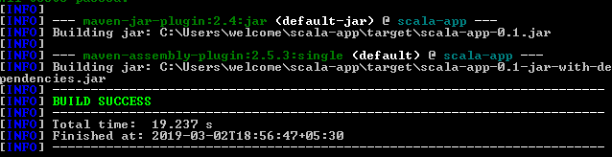

To execute the jar and see the output

Go to the target folder using cd

Type java –jar jar-name.jar

C:\Users\welcome\Desktop\step 5.PNG

Output

